25.8.5 Editors - Properties Editor - Modifiers Tab - Color Modifiers
Detailed table of content 1
Color modifiers 4
Hue/Saturation Modifier 4
Opacity Modifier 6
Texture Mapping modifier 9
Tint Modifier 10

Detailed table of content

Detailed table of content
Detailed table of content 1
Color modifiers 4
Hue/Saturation Modifier 4
Mode 4
Hue 4
Saturation 4
Value 4
Influence 4
Layer 4
Invert 4
Pass 4
Invert 5
Material 5
Invert 5
Pass 5
Invert 5
Custom Curve 5
Navigation elements 5
Zoom in and out 5
Tools 5
Reset View 5
Vector Handle 5
Auto Handle 5
Auto Clamped Handle 5
Extend Horizontal 6
Extend Vertical 6
Reset Curve 6
Use Clipping 6
Delete Points 6
Curve window 6
X / Y 6
Opacity Modifier 6
Mode 6
Uniform Opacity 7
Opacity Factor 7
Influence 7
Layer 7
Invert 7
Pass 7
Invert 7
Material 7
Invert 7
Pass 7
Invert 7
Vertex Group 7
Invert 7
Custom Curve 8
Navigation elements 8
Zoom in and out 8
Tools 8
Reset View 8
Vector Handle 8
Auto Handle 8
Auto Clamped Handle 8
Extend Horizontal 8
Extend Vertical 8
Reset Curve 8
Use Clipping 8
Delete Points 8
Curve window 9
X / Y 9
Texture Mapping modifier 9
Mode 9
Stroke Fit Method 9
UV Offset 9
Scale 9
Influence 9
Layer 9
Invert 9
Pass 9
Invert 10
Material 10
Invert 10
Pass 10
Invert 10
Vertex Group 10
Invert 10
Tint Modifier 10
Mode 10
Strength 10
Tint Type 11
Uniform 11
Color 11
Gradient 11
Color Ramp 11
Controls 11
+ 11
- 11
Tools menu 11
Flip Color Ramp 11
Distribute Stops from Left 11
Distribute Stops Evenly 11
Eyedropper (pipette icon) E 11
Reset Color Ramp 11
Color Mode 11
RGB 11
HSV/HSL 11
Interpolation 11
Ease 11
Cardinal 12
Linear 12
B-Spline 12
Constant 12
Color Ramp 12
Active Color Stop elements 12
Choose active color stop 12
Pos 12
Object 12
Radius 12
Influence 12
Layer 12
Invert 12
Pass 12
Invert 12
Material 13
Invert 13
Pass 13
Invert 13
Vertex Group 13
Invert 13
Custom Curve 13
Navigation elements 13
Zoom in and out 13
Tools 13
Reset View 13
Vector Handle 13
Auto Handle 14
Auto Clamped Handle 14
Extend Horizontal 14
Extend Vertical 14
Reset Curve 14
Use Clipping 14
Delete Points 14
Curve window 14
X / Y 14

Color modifiers
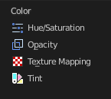
Color modifiers just exists for the Grease Pencil object.

Hue/Saturation Modifier
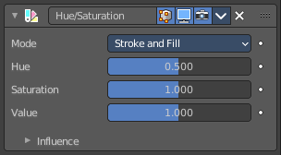
The Hue/Saturation Modifier applies a color transformation to the object output color.

Mode
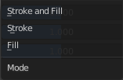
The color transformation will be applied on the stroke and/or the fill color.
Stroke and Fill, Stroke, Fill

Hue
Specifies the hue rotation of the image. 360° are mapped to (0 to 1). The hue shifts of 0 (-180°) and 1 (+180°) have the same result.

Saturation
A saturation of 0 removes hues from the image, resulting in a greyscale image. A shift greater than 1.0 increases saturation.

Value
Value is the overall brightness of the image. De/Increasing values shift an image darker/lighter.

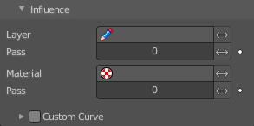
Influence

Layer
Restricts the effect only to one layer or to any layers that share the same pass index. Click to pick the layer that you want to use.

Invert
Inverts the influence.

Pass
The layer pass index.

Invert
Inverts the influence.

Material
Restricts the effect only to material that share the same material or pass index. Click to pick the material that you want to use.

Invert
Inverts the influence.

Pass
The material pass index.

Invert
Inverts the influence.

Custom Curve
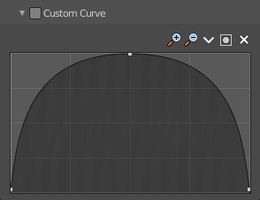
Use a custom curve to define the noise along the strokes.

Navigation elements
The navigation elements at the top are described from left to right.

Zoom in and out
The two buttons with the magnifying glass at it zooms in and out in the curve window.

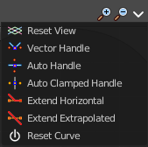
Tools
Tools is a menu where you can find some curve related tools.

Reset View
Resets the curve windows zoom.

Vector Handle
Set handle type to Vector.

Auto Handle
Set handle type to Auto.

Auto Clamped Handle
Set handle type to Auto Clamped.

Extend Horizontal
Extend the curve points horizontal before the first curve point and after the last curve point.

Extend Vertical
Extend the curve points vertical before the first curve point and after the last curve point.

Reset Curve
Resets the curve to the initial shape.

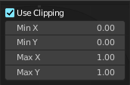
Use Clipping
Clipping options. Set up clipping for the stroke.

Delete Points
Deletes selected curve points.

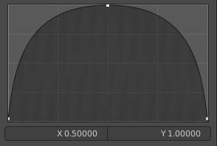
Curve window
Tweak and adjust the falloff curve by clicking at a curve point and dragging it around.
Double click adds a new point.
Holding down ctrl activates temporary snapping.
Holding down shift enables slower movement, which allows more accurate setting.

X / Y
The position of the currently selected curve point.

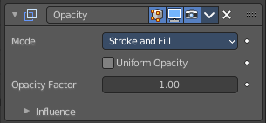
Opacity Modifier
The Opacity Modifier change the opacity (alpha) value of the stroke points.
The alpha value in Grease Pencil is stored per-point. The modifier can alter these values to go from totally transparent points to totally opaque points.

Mode
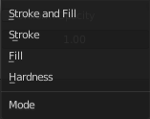
The color transformation will be applied to the stroke/fill color or stroke Hardness. When Hardness is selected, then the opacity affects the stroke’s transparency (alpha) from the center to the border.
Stroke and Fill, Stroke, Fill, or Hardness.

Uniform Opacity
When enabled, makes the opacity equal for the entire strokes.

Opacity Factor
Controls the opacity value of the stroke points. A value of 1.0 respect the original alpha value of the points, a shift less than 1.0 make the points more transparent than originally, and a shift greater than 1.0 make the points more opaque than originally.
Sets value to 2.0 makes the points alpha fully opaque.

Influence

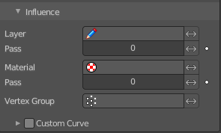
Layer
Restricts the effect only to one layer or to any layers that share the same pass index. Click to pick the layer that you want to use.

Invert
Inverts the influence.

Pass
The layer pass index.

Invert
Inverts the influence.

Material
Restricts the effect only to material that share the same material or pass index. Click to pick the material that you want to use.

Invert
Inverts the influence.

Pass
The material pass index.

Invert
Inverts the influence.

Vertex Group
Limit the influence to a vertex group.

Invert
Inverts the influence.

Custom Curve
Use a custom curve to define the noise along the strokes.

Navigation elements
The navigation elements at the top are described from left to right.

Zoom in and out
The two buttons with the magnifying glass at it zooms in and out in the curve window.

Tools
Tools is a menu where you can find some curve related tools.

Reset View
Resets the curve windows zoom.

Vector Handle
Set handle type to Vector.

Auto Handle
Set handle type to Auto.

Auto Clamped Handle
Set handle type to Auto Clamped.

Extend Horizontal
Extend the curve points horizontal before the first curve point and after the last curve point.

Extend Vertical
Extend the curve points vertical before the first curve point and after the last curve point.

Reset Curve
Resets the curve to the initial shape.

Use Clipping
Clipping options. Set up clipping for the stroke.

Delete Points
Deletes selected curve points.

Curve window
Tweak and adjust the falloff curve by clicking at a curve point and dragging it around.
Double click adds a new point.
Holding down ctrl activates temporary snapping.
Holding down shift enables slower movement, which allows more accurate setting.

X / Y
The position of the currently selected curve point.

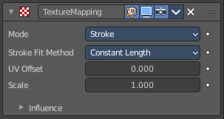
Texture Mapping modifier
Change stroke UV texture values.

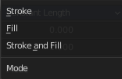
Mode
What to manipulate.

Stroke Fit Method
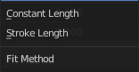
How to fit the length.

UV Offset
UV offset to add to the stroke UV's.

Scale
Factor to scale the UV's.

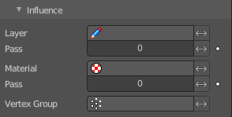
Influence

Layer
Restricts the effect only to one layer or to any layers that share the same pass index. Click to pick the layer that you want to use.

Invert
Inverts the influence.

Pass
The layer pass index.

Invert
Inverts the influence.

Material
Restricts the effect only to material that share the same material or pass index. Click to pick the material that you want to use.

Invert
Inverts the influence.

Pass
The material pass index.

Invert
Inverts the influence.

Vertex Group
Limit the influence to a vertex group.

Invert
Inverts the influence.

Tint Modifier
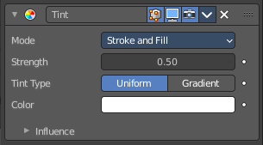
The Tint Modifier colorize the original stroke or fill with a selected color.

Mode
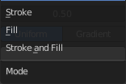
The color transformation will be applied on the stroke and/or the fill color.
Stroke and Fill, Stroke, Fill

Strength
Controls the amount for the color mixing.
A value of 0 respect the original strokes vertex color, a value of 1.0 totally replace the original color with the tint color.
A shift greater than 1.0 will make the points alpha less transparent than originally (2.0 is fully opaque).

Tint Type

Uniform

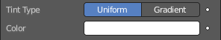
Color
Defines the tint color for mixing with the original color.

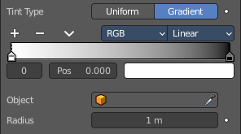
Gradient

Color Ramp
Defines the tint gradient color for mixing with the original vertex color.

Controls

+
Add a stop to your color ramp. The stop will be added after the selected one, in the middle to the next one.

-
Deletes the selected color stop from the list.


Tools menu

Flip Color Ramp
Flips the gradient, inverting the values of the color ramp.

Distribute Stops from Left
Rearrange the stops so that every step has the same space to the right.

Distribute Stops Evenly
Space between all neighboring stops becomes equal.

Eyedropper (pipette icon) E
An Eyedropper to sample a color or gradient from the interface to be used in the color ramp.

Reset Color Ramp
Resets the color ramp to its default state.


Color Mode

RGB
Blends color by mixing each color channel and combining.

HSV/HSL
Blends colors by first converting to HSV or HSL, mixing, then combining again. This has the advantage of maintaining saturation between different hues, where RGB would de-saturate, this allows for a richer gradient.


Interpolation

Ease
Uses an Ease Interpolation for the color stops.

Cardinal
Uses a Cardinal Interpolation for the color stops.

Linear
Uses a Linear Interpolation for the color stops.

B-Spline
Uses a B-Spline Interpolation for the color stops.

Constant
Uses a Constant Interpolation for the color stops.

Color Ramp
The color band. A click at one of the color stops makes it the active one. You can move the color stops by clicking at them and dragging them around.

Active Color Stop elements
Adjust the active color stop.

Choose active color stop
Choose the color stop by index.

Pos
The position of the active color stop. The range goes from 0.000 to 1.000.

Object
A Data ID to select an object (usually an empty), which position and rotation will be used to define the center of the effect.

Radius
Defines the maximum distance of the effect.

Influence

Layer
Restricts the effect only to one layer or to any layers that share the same pass index. Click to pick the layer that you want to use.

Invert
Inverts the influence.

Pass
The layer pass index.

Invert
Inverts the influence.

Material
Restricts the effect only to material that share the same material or pass index. Click to pick the material that you want to use.

Invert
Inverts the influence.

Pass
The material pass index.

Invert
Inverts the influence.

Vertex Group
Limit the influence to a vertex group.

Invert
Inverts the influence.

Custom Curve
Use a custom curve to define the noise along the strokes.

Navigation elements
The navigation elements at the top are described from left to right.

Zoom in and out
The two buttons with the magnifying glass at it zooms in and out in the curve window.

Tools
Tools is a menu where you can find some curve related tools.

Reset View
Resets the curve windows zoom.

Vector Handle
Set handle type to Vector.

Auto Handle
Set handle type to Auto.

Auto Clamped Handle
Set handle type to Auto Clamped.

Extend Horizontal
Extend the curve points horizontal before the first curve point and after the last curve point.

Extend Vertical
Extend the curve points vertical before the first curve point and after the last curve point.

Reset Curve
Resets the curve to the initial shape.

Use Clipping
Clipping options. Set up clipping for the stroke.

Delete Points
Deletes selected curve points.

Curve window
Tweak and adjust the falloff curve by clicking at a curve point and dragging it around.
Double click adds a new point.
Holding down ctrl activates temporary snapping.
Holding down shift enables slower movement, which allows more accurate setting.

X / Y
The position of the currently selected curve point.

